9-13 Parramatta Road Underwood, 4119
P (07)3808 1343
F (07) 3808 6721
www.mycabinetmaker.com.au
ABN: 99 062 146 687
QBCC License: 066875

WARRANTY & GENERAL CARE MAINTENANCE INFORMATION

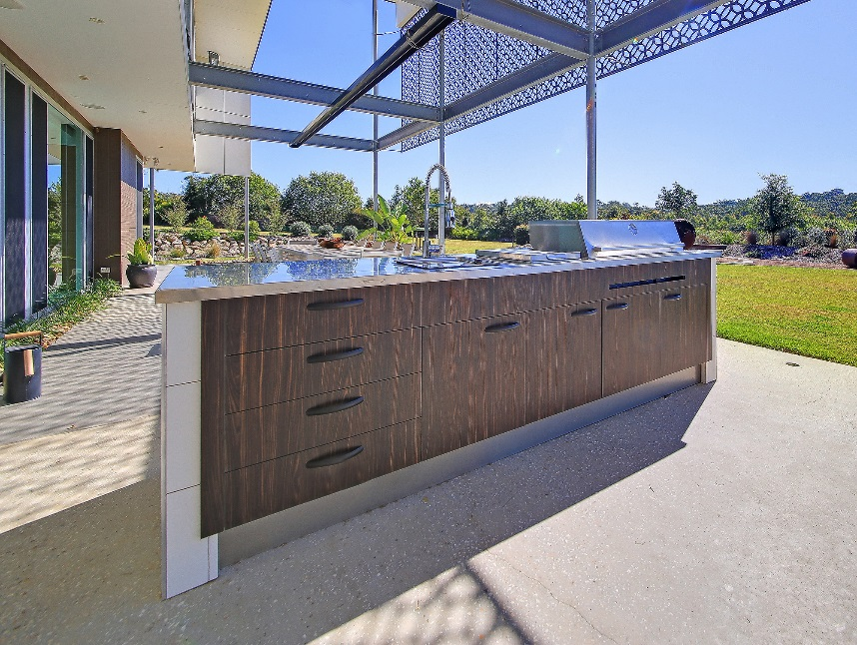
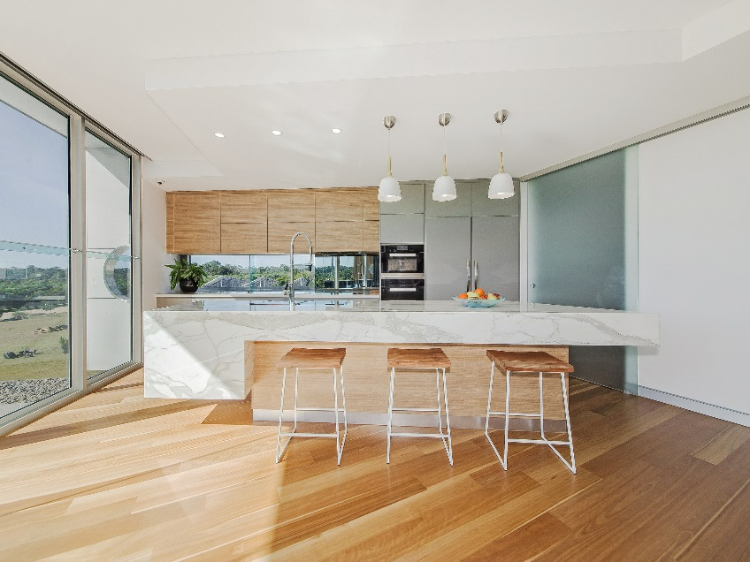
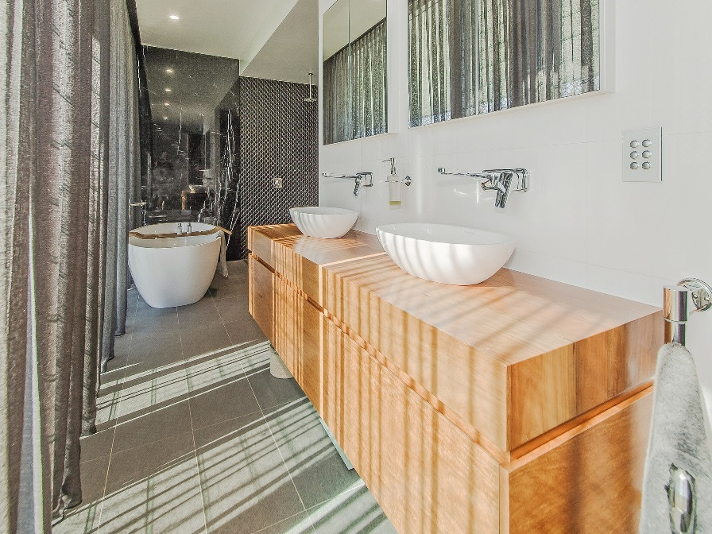
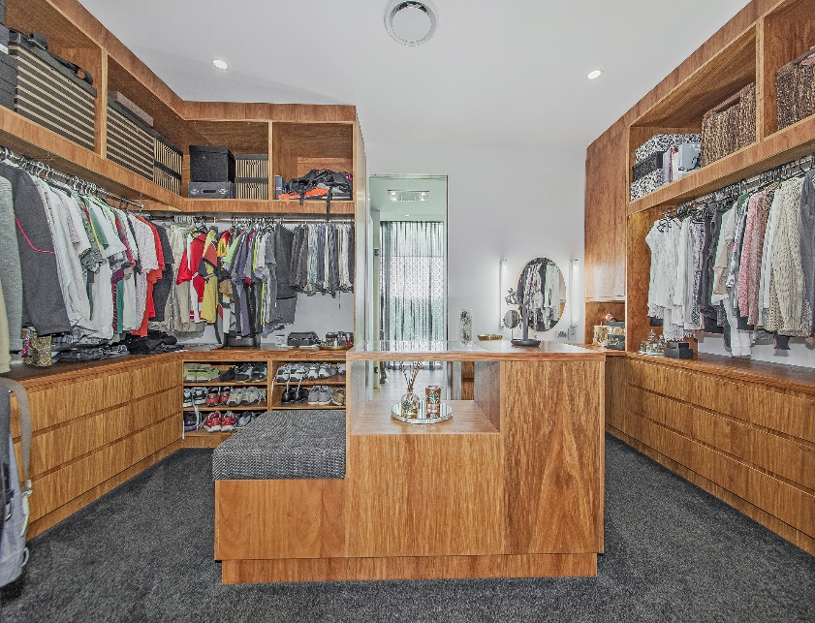

9-13 Parramatta Road Underwood, 4119
P (07)3808 1343
F (07) 3808 6721
www.mycabinetmaker.com.au
ABN: 99 062 146 687
QBCC License: 066875

WARRANTY REGISTRATION FORM

CLIENTS NAME:___________________________________________

DATE OF JOB COMPLETION:__________________________________

QUOTATION NUMBER: __________________________________

JOB LOCATION:____________________________________________

Dear Client,

Thank you for choosing Facoory Cabinetry for your cabinetry requirements. We hope that you are very happy with your finished product and have many years of trouble free enjoyment.

Your cabinets are covered by a 12 months warranty from date of install and final invoice which covers all cabinets, hardware and bench tops for defects in this period. We use only the highest quality Blum hinges and drawer runners which are covered by a lifetime warranty. Although the hardware is of the highest quality, should there be a problem in the first 12 months, we will happily replace it at our expense. After 12 months, you will need to contact Blum directly to organise replacements. Please read the attached Blum warranty brochure for more details and register your lifetime warranty directly with Blum by visiting https://www.blum.com/us/en/02/60/20/

If you have Stone Benchtops please refer to the attached website links for more warranty details (Page 8)

As we want your cabinets to stay new for many years to come, we have provided the following an outline of general care & maintenance procedures to help keep your cabinets and stone benchtops looking great.

Please take the time to peruse the attached information.

Kind regards,

Dale Facoory/ Shane & Gem Walker
9-13 Parramatta Road Underwood, 4119
P (07)3808 1343
F (07) 3808 6721
www.mycabinetmaker.com.au
ABN: 99 062 146 687
QBCC License: 066875

GENERAL CARE & MAINTENANCE PROCEDURES

CABINET CARCASS

General Care - Information
• Avoid scourers and abrasives as they will damage the surface.
• Don't cut on the surface.
• Keep waxes and polishes well away as they dull the natural shine.
• Do not use strongly acidic, alkaline cleaners or bleach for normal cleaning as these might etch the surface.

General Care - Grease
• Use a mild dishwashing detergent in water to remove greasy marks. Dab, wait and wipe away. Finish with an all-purpose cleaner such as Windex spray cleaner or Ajax Spray ‘n’ Wipe.

General Care – Spills
• Melamine surfaces resist staining from most household chemicals. With some accidental spills however, prompt action is essential. Wipe off beetroot, grape and berry juices, first aid preparations, concentrated bleach, oven cleaners, dishwasher detergents, artificial dyes, hair colouring and solvent based pen ink immediately. Specialty glues such as Super Glue must also be removed straight away with acetone (nail polish remover).

General Care - Stains • If the stain won't budge with Extra Strength Windex, try methylated spirits or dab the stain with a diluted bleach mixture (1-part bleach to 8 parts water); leave for 3 minutes then wash off with water and dry. Finish off with Extra Strength Windex. Only as a last resort if a stain persists try 2 or 3 rubs with a crème cleanser or white toothpaste, wash and dry. Please note that bleach or these abrasive cleaners may irreversibly damage the laminate surface.

General Care – Scratches
• Melamine surfaces will withstand normal wear and tear, but can be damaged by scratching or cutting with utensils, knives and unglazed pottery. To minimise scratching, always place and lift objects from the surface – never drag or slide them across the surface.

9-13 Parramatta Road Underwood, 4119
P (07)3808 1343
F (07) 3808 6721
www.mycabinetmaker.com.au
ABN: 99 062 146 687
QBCC License: 066875

CABINET FACES

General Care - Information
• Avoid scourers and abrasives as they will damage the surface. • Don't cut on the surface. • Keep waxes and polishes well away as they dull the natural shine. • Do not use strongly acidic, alkaline cleaners or bleach for normal cleaning as these might etch the surface.

General Care – Streaks
• Streaky marks sometimes show on dark colours after cleaning. An all-purpose cleaner such as Windex spray cleaner or Ajax Spray ‘n’ Wipe usually removes them.

General Care – Grease
• Use a mild dishwashing detergent in water to remove greasy marks. Dab, wait and wipe away. Finish with an all-purpose cleaner such as Windex spray cleaner or Ajax Spray ‘n’ Wipe.

General Care - Spills
• Melamine surfaces resist staining from most household chemicals. With some accidental spills however, prompt action is essential. Wipe off beetroot, grape and berry juices, first aid preparations, concentrated bleach, oven cleaners, dishwasher detergents, artificial dyes, hair colouring and solvent based pen ink IMMEDIATELY. Specialty glues such as Super Glue must also be removed straight away with acetone (nail polish remover).

General Care – Stains
• If the stain won't budge with Extra Strength Windex, try methylated spirits or dab the stain with a diluted bleach mixture (1-part bleach to 8 parts water); leave for 3 minutes then wash off with water and dry. Finish off with Extra Strength Windex. Please note that bleach or these abrasive cleaners may irreversibly damage the laminate surface.

General Care - Scratches
• Melamine surfaces will withstand normal wear and tear, but can be damaged by scratching or cutting with utensils, knives and unglazed pottery. Darker colours will show scratches more readily than lighter colours. In general, dark colours and high gloss surfaces require more care and maintenance than lighter colours or lower gloss colours. To minimise scratching, always place and lift objects from the surface – never drag or slide them across the surface.

9-13 Parramatta Road Underwood, 4119
P (07)3808 1343
F (07) 3808 6721
www.mycabinetmaker.com.au
ABN: 99 062 146 687
QBCC License: 066875

CABINET & HINGES & DRAWER RUNNERS

General Care – Information
• Drawer runners are maintenance free but scourers and abrasives must be avoided as they will damage the surface. Do not use strongly acidic, alkaline cleaners or bleach for normal cleaning as these might etch the surface.

CABINET HANDLES

General Care – Information
• Use a damp cloth to wipe away any grease or marks and dry with a clean soft cloth. • Scourers and abrasives must be avoided as they will damage the surface. • Do not use strongly acidic, alkaline cleaners or bleach for normal cleaning as these might etch the surface

LAMINATED BENCHTOPS

General Care - Information
• Avoid scourers and abrasives as they will damage the surface.
• Don't place hot objects, electrical appliances or pots straight from the oven or cooker onto your laminate surface.
• Don't cut on the laminate surface.
• Keep waxes and polishes well away as they dull the natural shine.
• Do not use strongly acidic, alkaline cleaners or bleach for normal cleaning as these might etch the surface.
• When cleaning streaks, spills and grease, wipe in circular motions

General Care – Streaks
• Streaky marks sometimes show on dark colours after cleaning. An all-purpose cleaner such as Windex spray cleaner or Ajax Spray ‘n’ Wipe usually removes them.

General Care - Grease
• Use a mild dishwashing detergent in water to remove greasy marks. Dab, wait and wipe away. Finish with an all-purpose cleaner such as Windex spray cleaner or Ajax Spray n Wipe.
9-13 Parramatta Road Underwood, 4119
P (07)3808 1343
F (07) 3808 6721
www.mycabinetmaker.com.au
ABN: 99 062 146 687
QBCC License: 066875

General Care - Spills
• Laminate surfaces resist staining from most household chemicals. With some accidental spills however, prompt action is essential. Wipe off beetroot, grape and berry juices, first aid preparations, concentrated bleach, oven cleaners, dishwasher detergents, artificial dyes, hair colouring and solvent based pen ink IMMEDIATELY. Specialty glues such as Super Glue must also be removed straight away with acetone (nail polish remover).

General Care – Stains
• If the stain won't budge with Extra Strength Windex, try methylated spirits or dab the stain with a diluted bleach mixture (1-part bleach to 8 parts water); leave for 3 minutes then wash off with water and dry. Finish off with Extra Strength Windex. Please note that bleach or these abrasive cleaners may irreversibly damage the laminate surface.

General Care - Scratches
• Laminate surfaces will withstand normal wear and tear, but can be damaged by scratching or cutting with utensils, knives and unglazed pottery. Darker colours will show scratches more readily than lighter colours. In general, dark colours and high gloss surfaces require more care and maintenance than lighter colours or lower gloss colours. To minimise scratching, always place and lift objects from the surface – never drag or slide them across the surface.

Specific Care - Laminex Laminates
This applies to Squareform Benchtops, Fire Retardant Laminates, Chemical Resistant Laminates, Aquapanel Wet Area Panelling, Vizage Wall Lining, Fusion Laminates and Compact Laminate.

• A damp cloth will remove spills and greasy spots. Rub with a clean dry cloth in a circular motion to bring back brightness. Occasionally clean with a mild dishwashing detergent. To remove heavy build-up of dirt use cleaners such as Mr Muscle, Windex or Ajax Spray ‘n’ Wipe spray cleaners.

9-13 Parramatta Road Underwood, 4119
P (07)3808 1343
F (07) 3808 6721
www.mycabinetmaker.com.au
ABN: 99 062 146 687
QBCC License: 066875

NATURAL AND RECONSTITUTED STONE BENCHTOPS

Also known as “engineered stone”, reconstituted stone is made from 90-95% quartz that is bound with resins and colours. The slabs are formed under enormous pressure and heat treated, therefore becoming extremely strong and non-porous. Natural and reconstituted stone require little maintenance, however if you follow a few simple rules your stone bench tops will look new forever.

1. Always clean surface with a damp soft cloth or a non-scratch cleaning pad, on a regular basis particularly high traffic areas.

2. Avoid the use of abrasive cleaners or products containing acids, vinegar or lemon juice to clean your stone bench tops. Use warm soapy water instead, then a soft drying cloth. For stubborn stains, a specialized cream cleanser can be used.

3. Although stone is highly resistant to heat any material can potentially be damaged by sudden and rapid temperature changes. It is therefore not advisable to place hot saucepans directly off the stove onto your benchtops however warm substances will not cause any damage. The use of a hot pad is advised.

4. Granite and Marble are porous products which could stain if sufficient care is not taken. Although all bench tops are sealed prior to leaving our factory some substances particularly oil, juices, sauces, wines and soft drinks could penetrate the surface of the bench tops leaving a stain. To avoid this simply wipe down immediately.

With proper care and common sense, you can expect your stone benchtops to maintain their lustre and shine for many years and will look as good as the day they were installed.
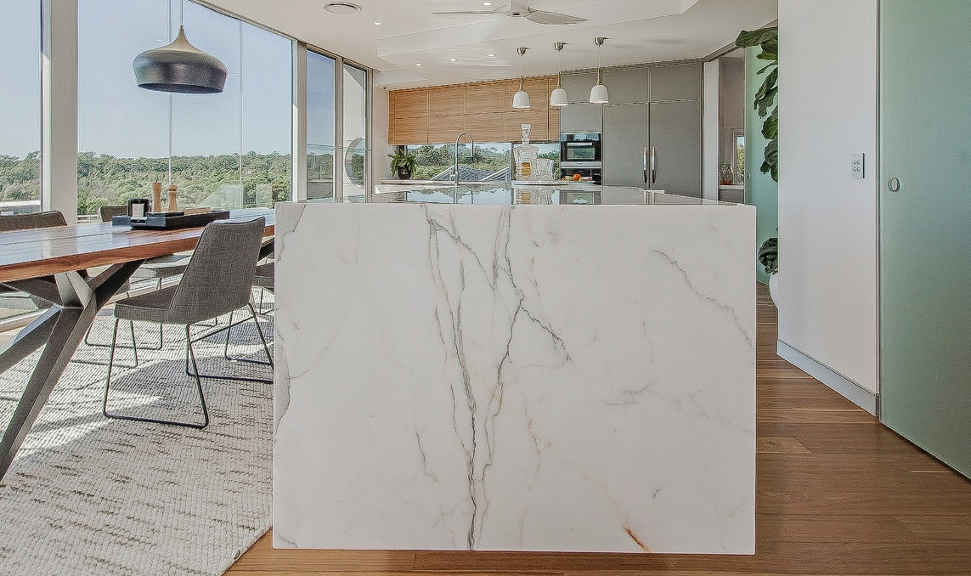

9-13 Parramatta Road Underwood, 4119
P (07)3808 1343
F (07) 3808 6721
www.mycabinetmaker.com.au
ABN: 99 062 146 687
QBCC License: 066875

WARRANTY LINKS

Caesar Stone Warranty:
http://www.caesarstone.com.au/Portals/0/Documents/2013%20Caesarstone%2010%20Year%20Limited%20Warranty.pdf

Essastone Warranty:
http://www.essastone.com.au/uploads/warranty/Essastone-Warranty-Care-MaintenanceCard-2016.PDF

Smart Stone Warranty:
http://www.smartstone.com.au/wp-content/uploads/2014/10/Smartstone_Warranty.pdf

Quantum Quartz Warranty:
http://www.wk.com.au/Files/Files/QQ-Warranty.pdf

Silestone Warranty:
https://content.cosentino.com/silestone/documents-usa/For%20The%20Trade/Warranty%20Information/Silestone-Warranty.pdf

Laminex Warranty:
http://www.laminex.com.au/uploads/tech-info/Laminates%20Warranty%204-12.pdf
Care & Maintenance:
http://www.laminex.com.au/uploads/tech-info/Care%20and%20Maintanence.pdf

Polytec Warranty:
https://www.polytec.com.au/docs/technical/polytec-technical-warranty-terms-and-conditions.pdf
Care & Maintenance:
https://www.polytec.com.au/docs/technical/polytec-technical-thermolaminated-care.pdf

Formica Warranty:
file:///C:/Users/User/Downloads/AUWarrantyDecoratedParticleboardpdf.pdf
Care & Maintenance:
http://www.formica.com/en/us/advice-and-ideas/formica-laminate-cleaning

